Royal Oak Farm LLC. Waterlick Location 697 Waterlick Road
Lynchburg, VA. 24501
Phone: 434-665-07 43
Email: royaloakfarmllc@gmail.com Website: royaloakfarmllc.com
2026

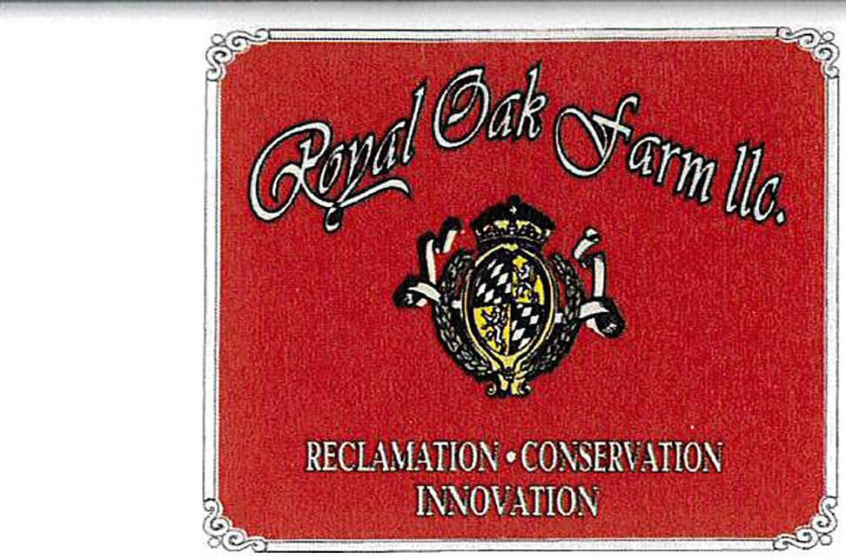
STONE
1/4" - 1/2" White Pea Gravel 7/8" White Stone
1/4" - 1/2" Brown Pea Gravel 3/4" - 1 3/4" Brown River Rock 2" - 4" Brown River Rock
4" - 7" Brown River Rock

SAND

Masonary Sand Horse Ring Sand White Play Sand

GRAVEL

Crusher Run # 57
#68
#40
Rip Rap
Slag
Asphalt Millings
Crushed Concrete
Brick Chips
MULCH
Erosion Mulch
Single Ground
Double Ground Hdwd
Triple Ground Hdwd
Dyed Black
Dyed Brown
Pine Fines
Pine Sawdust
Wood Chips
SOILS
Enriched Topsoil
Garden Compost
Native Screened Topsoil
Native Fill Dirt
Leaf Compost
Container Mix w/ Perlite

LANDSCAPE MATERIALS
LSF (3x250)
LSF (4x250)
LSF (6x250)
Woven Geo 200 lb. (12.5x432)
Woven Geo 300 lb. (12.5x360)
Non Woven 6 oz. (12.5x360)
Non Woven 4 oz. (12.5x360)
Blanket Single Net Straw (8x112.5)
Blanket Single Net Straw (4x112.5)
Staples 6 inch (1000/box)
Pins Circle Top (1000/box)
Contractors Mix 70/30 (50 lb.)
SLB Southern Lawn (50 lb.)
Nutriscape 10-20-5 20%XCU (50 lb.
Pelletized Lime Standard (50 lb.)
SF Black (36x100 w/ 18 stakes)
Premium Ice Melt (per bag)
Pallet of Premium Ice Melt (per bag)
4' Wood Stakes (per bundle)
5' Wood Stakes (per bundle)
Perlite (per bag)
Garden Tone (8 lb. bag)
Bales of Straw
STUMPS & BRUSH ACCEPTED
Stumps & Brush
Leaves
OTHER ACCEPTED
Wood Chips (free if clean)
Concrete (free if clean)
Blacktop (free if clean)
Fill Dirt (free if clean)

**** for price inquire at office

We have a quantity calculator on our website.

1 scoop = approxiametly 1 cubic yard which covers 150 square feet at 2" deep.

